Workforce Management Solution Finds Superior Technology to Improve Their Microsoft 365

Employee Experience Inc
Employee Experience Inc is a workforce management solution based in the Midwest.

Requirements
Employee Experience Inc had been using Microsoft Defender to protect their Microsoft 365 environment, but far too many threats were entering the inbox, and visibility and reporting tools were limited. They were looking for a solution that caught more phishing, had an easy-to-use UI and simply did more than Microsoft did.

Cloud Suite
Microsoft 365

Previous Email Security Solution
Microsoft Defender

Background

Andrew Fox† runs the IT Department for Employee Experience Inc, a workforce management solution in the Midwest.

They had been using Microsoft Defender to protect their Microsoft 365 environment, but they were very disappointed. Far too many threats were entering the inbox, and the UI, as he said, “wasn’t from this decade.”

One of their top competitors was hit with a ransomware attack, making that a top priority. They knew that the best way to prevent ransomware was to prevent phishing, so they were particuarly interested in a solution that could effectively filter malicious messages from the inbox.

They already knew that they needed to supplement Microsoft, and wanted to do so with an API-based solution.

They had a few key requirements:

- They needed a solution that caught phishing at a much higher rate than Microsoft
- They needed a clean and easy to use UI
- They needed protection to extend to their SaaS apps, like Slack
- And they needed easy-to-understand reports that showed the improvement over Microsoft.

After looking at reviews, Fox decided to place two security solutions into POC: Avanan and Abnormal.

“Avanan has the Superior Technology”
Comparing Avanan and Abnormal gave Fox an easy-to-understand look at the key differentiators between the products.

Abnormal will pull out a malicious email after it reaches the inbox. They cannot stop a malicious message from reaching the inbox, signifying no improvement over Microsoft. If the removal happens instantly, it might be okay. However, according to research from Avanan, on average, it takes these solutions three minutes and three seconds to remediate and remove a malicious email from the inbox. Depending on the environment, that number can skyrocket even higher. Further, more research has shown that it takes, on average, 82 seconds for a user to click on a phishing attack.

Here’s what it looks like:

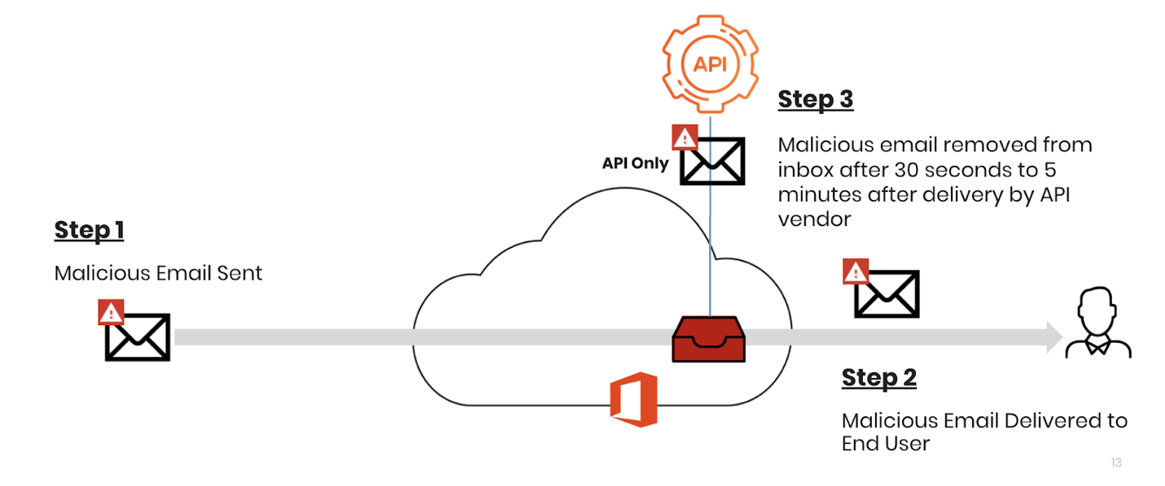

This process is reactive and doesn’t help with threats already in the system. When a dangerous message hits the environment, it’s already too late.

Avanan does things differently. Though it connects via API, it sits inline, blocking bad emails before the inbox.

“Looking at the differences, it was clear that Avanan had the superior technology,” he said.

Fox thought that Avaann’s solution resulted in fewer false positives and more threats caught. Plus, it extended security to his SaaS apps, like Slack.

With Avanan’s dashboard, he can see exactly what Microsoft has caught, and then what Avanan has blocked in addition. “That shows me how well the system is working,” he says.

“We’re More Secure”
Andrew Fox had been using Microsoft Defender to secure their Microsoft 365 environment.

But threats were still coming through. And when a competitor got hit with ransomware, he knew he needed to act.

He was looking for a solution that caught far more threats than Microsoft, while also providing an interface that was sleek and modern. He needed security that extended to his SaaS apps, and one that showedparticularly,, in detail, how effective it was.

That’s what Avanan does.

With Avanan in place, they saw a significant reduction in phishing emails reaching the inbox.

“We’re more secure,” he says.

†Company and individual names have been changed, but are available as a reference customer.

