Keep it Simple: How Switching to Avanan Made Things Easier for This Property Management Firm

Home Management†
Home Management is a property management firm in the Southwest.

Requirements
Home Management had been using Mimecast for years. In addition to high costs, the small IT department felt that managing their email was taking too much time. Between complicated usage and lack of results, Home Management needed a simpler, cheaper and better alternative.

Cloud Suite
Microsoft 365

Previous Email Security Solution
Mimecast

Background

Dave Butler† runs the IT Department for Home Management, a company in the Southwest that offers property management.

For years, the company had used Mimecast to secure its Microsoft 365 environment. But problems were everywhere.

For starters, the product was too expensive for what they felt they were getting out of it. As an example, they were paying for Mimecast’s archiving system that they weren’t actually using.

Further, it was difficult to see what was going on in their environment. When something was blocked, Butler couldn’t figure out why. It was especially frustrating due to the high level of false positives, and due to the fact it was blocking a lot of legitimate emails.
Finally, the system was just plain complicated. Butler is a one-person IT department. That means he’s swamped, being pulled in hundreds of different directions. But he was bogged down with email. Mimecast was “a pain” to manage, and left him having to put aside other, critical tasks.

For Butler, a change needed to be made. “We needed something different,” he says.

“It’s Just So Simple”
Home Management had been using Mimecast for a few years but with little success.

For Butler, frustration was paramount. Every time there was an attack, he couldn’t figure out why it was stopped or not stopped. “There’s just a lack of transparency and visibility,” he says. “They’re not very transparent on why it was phishing. It’s pretty frustrating when you’re seeing high levels of false positives. And it’s even more frustrating when it was blocking a lot of legitimate emails.”

To allow emails to properly flow through, Butler had to set up tons of lists of permitted senders—even employees in HR. Simple messages related to timekeeping were getting picked up as spam. No matter how much he fussed with the system, the results weren’t there.

He was also concerned with Mimecast’s lack of internal email scanning. As an SEG, Mimecast blocks inbound and outbound email. By their very nature, sitting outside the email server, they are blind to emails within the organization. 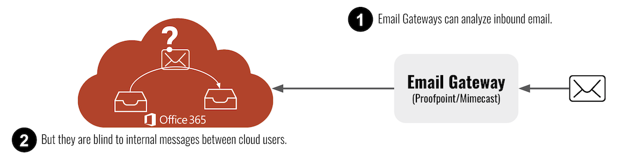

“It just wouldn’t catch a bad internal email,” Butler says. “And if there was a compromised account internally, it would be really bad.”

Beyond that, Butler spent so much time trying to get it to work properly, to no avail.

“Mimecast is pretty difficult to use,” he says. “Every time I ask for help, it’s like going down a rabbit hole. And when they try to explain something, it didn’t really make any sense.”
Butler had specific requirements for a new email security solution. For one, it needed to do a better job of handling false positives and it needed to let legitimate emails through.

Second, he needed something that was simpler to use. “I’m just looking for something that’s easy to use, not too much work on our end, runs in the background and does its job.”

After hearing about Avanan through its glowing reviews on Gartner and G2, Butler was eager to try. Almost immediately, he saw the benefit of the platform.

“It’s just so simple,” he says

On a demo and POC, Butler saw first-hand how Avanan’s powerful solution can work in the background, without him having to play around too much. On the POC, false positives dropped and more clean emails came through.

He was also excited about Avanan’s internal email protection. Because Avanan deploys inline, it can easily scan all internal emails. It also has the context needed to stop Business Email Compromise attacks, which prey on internal email.

“Everyone agrees that this is the way to go,” he says.

“It’s Just a Better Option”
Butler has been using Avanan for a little while now and couldn’t be happier.

“It’s just a better option,” he says.

He’s enjoyed the simplicity of Avanan’s solution. From the quick, one-click install, to easy configuration, everything has been much more efficient than when his company was using Mimecast.

He’s also appreciated that he’s paying for exactly what he’s using. Avanan is providing better security at a much better price.

Butler has also benefited from internal protection. He’s seen, in real-time, how Avanan’s inline protection has stopped potential account compromises from inside the company.

“Everything has worked out great,” he says.

“I Just Really Like The Solution”
After years of Mimecast protecting his O365 environment, Dave Butler was ready to stop being frustrated. He was frustrated by complicated configurations. He was frustrated by tons of false positives and too many legitimate emails being blocked.

He was frustrated that he was paying for services he wasn’t using and he was frustrating that trying to figure out the best way to utilize the service took time away from other pressing needs.

As a one-man IT department, Butler needed something simple, efficient and effective.

After tons of research, he came across Avanan and was impressed by the simplicity of their patented, inline solution API solution. He appreciated that configuration was a breeze and he felt more secure knowing that internal email was protected. All in all, it was a no-brainer to switch over.

“I just really like the solution,” he says.

†Company and individual names have been changed, but are available as a reference customer.

