The Modern Way of Doing Email Security Works Better for this Credit Union

Wildwood Credit Union†
Wildwood Credit Union is a credit union in the Pacific Northwest.

Requirements
Wildwood Credit Union had been using Proofpoint for several years and was becoming frustrated. Far too many malicious emails were getting into the inbox. Plus, they felt that the gateway setup was way out-of-date, necessitating a new approach to securing their email. Finally, since protecting personal identifying information is so critical, they needed a far more robust DLP solution.

Cloud Suite
Microsoft 365

Previous Email Security Solution
Proofpoint

Background

Alicia Scott† runs the IT Department for Wildwood Credit Union, a credit union in the Pacific Northwest.

For years, the company used Proofpoint to protect its environment. But after a while, Proofpoint began to disappoint.

For one, far too many phishing messages came through to the inbox. That was made worse since the pandemic, since, according to a report, 74% of banks and insurers have experienced a spike in cybercrime since the pandemic. In particular, there has been a 35% increase in phishing, a 35% increase in ransomware, and a 29% increase in internal threats. Wildwood needed a solution that could combat this rise.

Second, Scott noted that, “it feels like the technology is quite a few years behind.” As attacks continued to evolve, Scott thought they needed a security solution that evolved with these attacks.

Finally, they needed to secure all the personally identifiable information that entered their system.

For Scott, a change was needed. “We were all displeased with Proofpoint,” she said. “We needed better.”

“This Was Fantastic”
Scott’s first criteria was to get away from the gateway model that Proofpoint employs.

As she said, “We knew we had to get away from that proxy gateway setup, and have something that integrates via API.”

When doing her initial research, she noticed that there were two types of API solutions.

The first relied on detect and prevent. Other vendors offer Response: removing the email after it has already been delivered, typically after 30 seconds or more. For new, zero-day threats or malware that requires additional analysis, the delay can be measured in minutes or require manual intervention which could take much, much longer.

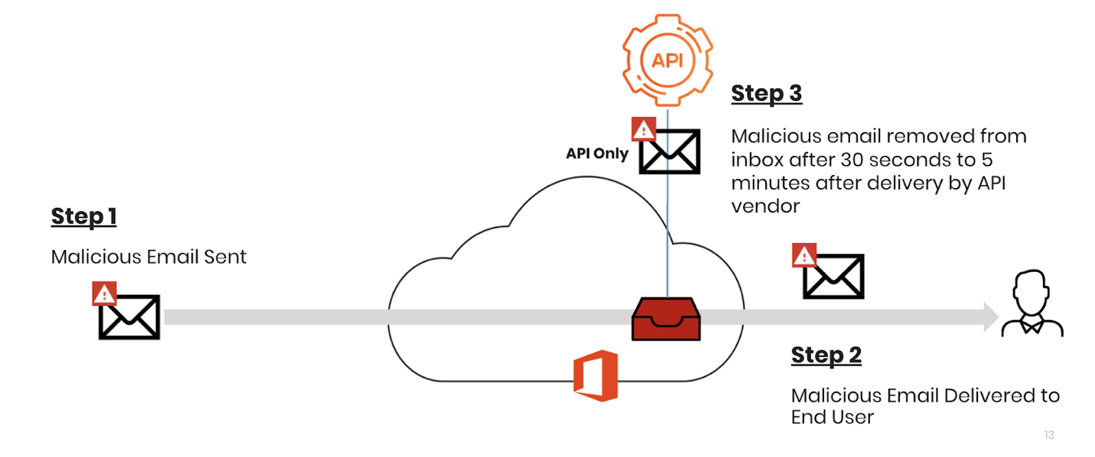
Avanan, she noticed, worked differently. Avanan offers Protection: preventing the malicious emails from reaching the end users.

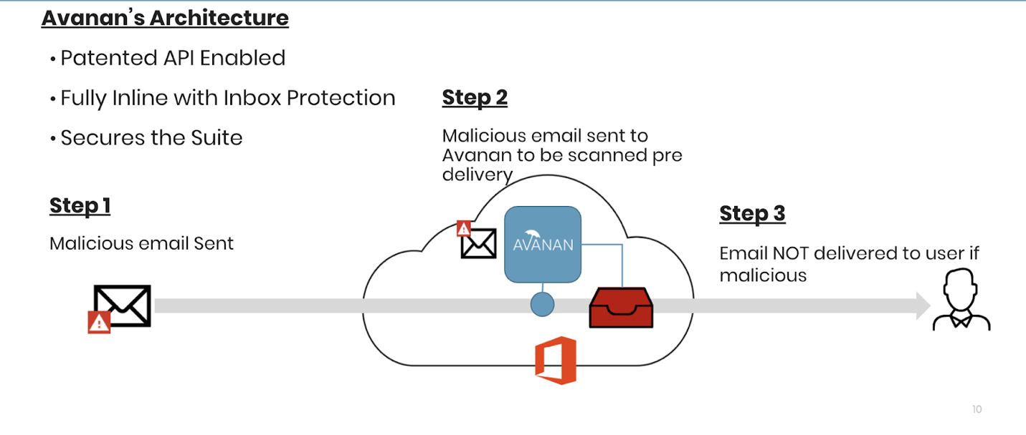

For Scott, this was a considerable development. Being able to completely block phishing messages from reaching the inbox would keep her users far safer.

“This is the kind of thing we’re looking for,” she says.

Secondly, Scott knew they needed to protect against data leakage. As a credit union, there are tons of personal data in their system, some of a person's most sensitive data. Protecting it was part of their mission.

When they tried out Avanan’s SmartDLP solution, they were impressed. With the Avanan solution, whenever sensitive info, like financial or personal, is detected, the content can be instantly quarantined. There can be a forced admin review or the admin can encrypt email to the rightful recipient. “This was fantastic,” she said.

Between the dramatic reduction in phishing messages reaching the inbox, the improved functionality and the impressive DLP program, Scott was convinced Avanan was the right choice.

“This is what we need,” she says.

“We Couldn’t Be Happier”
After using Proofpoint to protect their Microsoft 365 environment at Wildwood Credit Union, Alicia Scott was looking for a more modern, cloud-native option. She wanted to deploy security via API, do a better job of stopping phishing before it reached the inbox, and implement a strong DLP program.

After looking at the differences between detect-and-remediate API solutions--also known as helper apps, a term coined by Omdia--and full prevention APIs, in this case Avanan, Scott knew that blocking emails before the inbox made more sense. When she found out about Avanan’s robust DLP program, which was infinitely customizable, she was completely sold.

“This had everything we needed,” she says. “We couldn’t be happier.”

†Company and individual names have been changed, but are available as a reference customer.

